Task 1: Decorator
- The winter holidays will be here (again) before you know it! Being the organized individual you are, you have a plan for next year's holiday tree. Implement a software system that allows you to calculate the price of any tree plus any combination of decorations. The system must be easily extendable in the sense that whenever new decorations are added in the store you will have to at most add one class.
Here are two tables representing costs of trees and decorations, respectively

Name | Cost
Fraser Fir | 12
Douglas Fir | 15
Balsam Fir | 5
Colorado Blue Spruce | 20
Name | Cost
Star | 4
Ruffles | 1
Balls Red | 1
Balls Silver | 3
Balls Blue | 2
Ribbons | 2
Lights | 5
LEDs | 10

A very important requirement is that a tree can only have one star. When a user wants to decorate a tree with a star with a new star you must print a warning that the tree already has a star and not add the price of a star to tree. Users must be able to continue decorating their tree if they add another star to it:
Tree mytree = new BlueSpruce();
mytree = new Star(mytree);
mytree = new Ruffles(mytree);
mytree = new Star(mytree);
mytree = new Ruffles(mytree);
printtree(mytree);

should lead to:
Tree already has a star!
Blue spruce tree decorated with, a Star, Ruffles, Ruffles costs $26.00

- Draw a class diagram to illustrate your design.

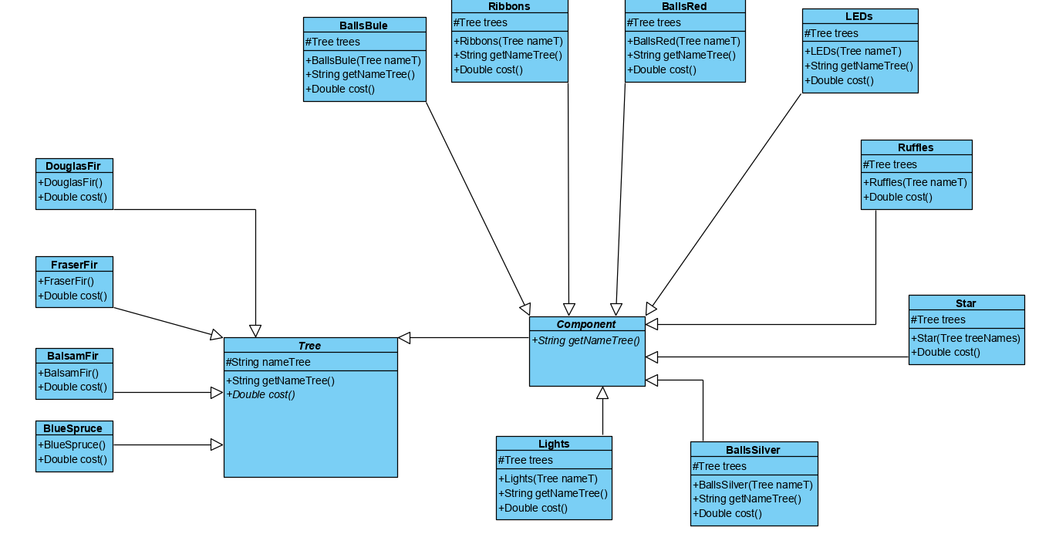

Task 2: Factory Method
- Big in Games (BIG) is a new slot machine manufacturer in Reno which is started by by disgruntled employees of Bally, IGT and Gametech whose non-competed clauses recently expired.
BIG seeks to offer slot machines at a significantly reduced price than their competitors and they seek to do this due to a more optimized software process for creating slot machines.
BIG aims to develop 3 different types of slot machines:
Straight Slots - are slot machines that only play slot games and pay out on the standard pay table.
Progressive Slots - progressive slots are linked to with other groups of machines in the same casino, or sometimes even groups of machines across a lot of casinos.
Bonus Game Slots - offer extra games when you get a certain combination of symbols on the reels. These extra games give you the chance to win extra money for no extra bets.
BIG aims to develop slot machines locally in the following states: New Jersey, Nevada and Washington and each state has different configuration with regard to the slot machine components. Every slot machine consists of four different physical components (“ingredients”): (1) a cabinet; (2) a system to receive payments from the user; (3) a display; and (4) a CPU. Slot machines are also shipped with a particular operating system. See the table for the specific configurations for each type of slot and state.

Implement a software system to support the development of slot machines using the Factory Method.
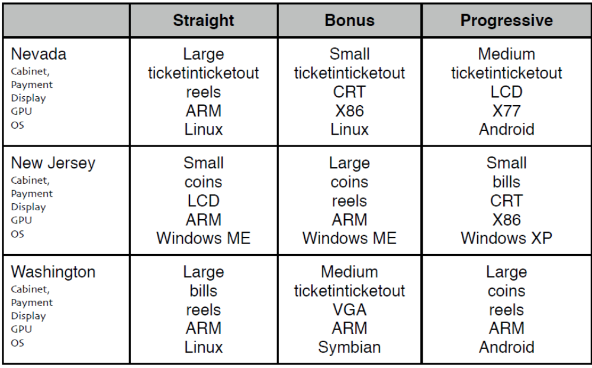ฑำ
- Draw a class diagram to illustrate your design.
